RESEARCH DESCRIPTION

- Purpose, Objectives, Design

Accuracy in dietary assessment is essential for understanding the role of ingestive behavior in energy balance and chronic disease risk. Traditional and commonly used methods for assessing dietary intake, such as weighed or estimated food records, 24h recalls, and food frequency questionnaires all rely on self-report and are participant to reporting bias, particularly underreporting of Energy Intake (EI). Errors in self-reported intake occur when participants incorrectly report portion sizes and/or foods consumed or change their eating behavior when asked to record intake. Estimates range from 10-50% on average, for underreporting of EI. Previous studies have explored the use of self-report in combination with technology to improve the accuracy of dietary assessment and estimating EI. Audio reports, photographic food records, personal digital assistants and smart cards are some of the methods investigated. Automatic methods for objective dietary assessment based on wearable sensors have been explored as a potential solution to replace self-reported intake. The technological advances in computer vision in recent years have also allowed the introduction of image/video analysis for diet assessment. Food imagery-based method acquires images before, during and after a meal using a wearable camera or a mobile device. However, it may suffer from the limitations of self-reported intake as individuals need to remember to take pictures of the foods before and after consumption. Methods to provide accurate detection and characterization of dietary intake with minimal or no conscious effort from the participants are therefore urgently needed.

With the objective of leveraging a wearable dietary intake-monitoring tool, this study aims at the development of an Automatic Ingestion Monitor (AIM) wearable device for automatic and objective food intake monitoring. Such a device:

- will allow the detection of food intake instances from other activities of daily living, such as walking, talking, sleeping, etc.
- will automatically capture high-quality, objective and maximally relevant images of food consumption, enabling accurate nutritional analysis towards developing energy intake models under free-living conditions.

The fundamental hypotheses of the study are:
1) Periods of food intake can be detected in free-living conditions by means of pattern recognition methods applied to signals from the AIM sensor.
2) The number and type of food items in a meal, caloric and nutritional content of a meal can be estimated by the analysis of the AIM images.
3) Informative food images can be separated from non-food images obtained by the AIM via an image clustering algorithm.
4) Energy intake estimates can be obtained using the derived models from the analysis of the AIM sensor signals and the AIM images.

In the proposed study, we will collect sensor data and images from the AIM while participants are wearing the AIM and a) performing a structured set of activities (including a complete meal) in the lab and then b) when living their normal lives in free living conditions. The data from both lab and free living conditions will be analyzed to test our hypotheses and to evaluate applicability of the AIM as a dietary assessment tool.

- Study Procedures

2.1 Measurement equipment
2.1.1 AIM Device
A total of two options for the AIM device will be explored to objectively detect each instance of food intake, microstructure parameters (e.g. chewing), and high-quality food images. The followings are the potential options (depicted in Figure -1):
a) An earpiece sensor consisting of an air pressure sensor (SM9541, from Silicon Microstructures) system and a custom molded earbud (Fig. 1a). The ear canal pressure can be analyzed to objectively detect and monitor food intake. Fig. 2 shows an example of the sensor signal acquired during a short episode of food intake. The number of chew counts can be obtained from the signal and can be used to objectively estimate energy intake. The earpiece will also contain a 5Mp camera facing down toward the food. Wide-angle lens camera captures accurate details of food being consumed at a rate of one image per 10 seconds. The food imagery is used to further improve accuracy of energy intake estimation. Fig. 3 shows examples of food images acquired by the AIM camera. All collected sensor signals and captured images are stored on SD card integrated in the AIM module for further offline processing in MATLAB (Mathworks Inc., Natick, MA, USA).
b) An eyeglasses sensor. The attachment to eyeglass frame will include a bending sensor (SpectraSymbol 2.2” flex sensor) that monitors the force applied by the temporalis muscle to the frame of the glasses and can be used to estimate chew counts. Other than difference in the sensor and form, the device operates the same as the earpiece sensor and provides the same information.
Data will be collected using both versions of AIM device. We expect approximately half of the population to be tested by the earpiece sensor and another half by the eyeglass sensor. The assignment to a specific option will be random, also taking into account the availability of a specific device at the time of the experiment.
AIM device is a non-significant risk device as it is not an implant, does not support life, does not present a health risk, and is not used in diagnosing or treating disease. AIM is based on low power, low-voltage (3V) electronics and poses no more than minimal risk, comparable to a consumer electronic device.
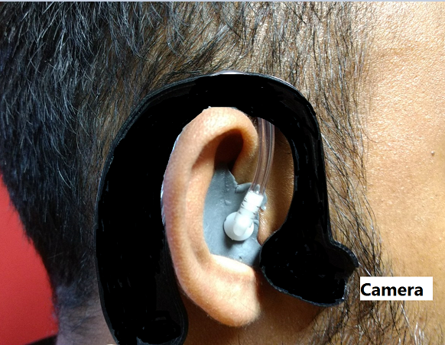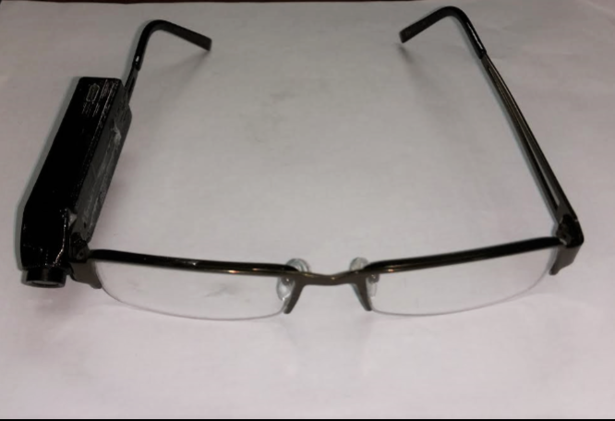
(a) (b)
Figure 1. Wearable systems: a) Earpiece sensor c) Eyeglass sensor.
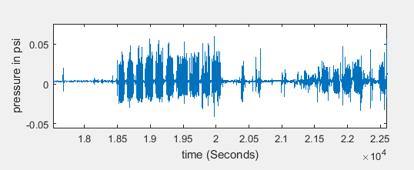
Figure 2. Example of a signal from the pressure sensor placed on the earpiece

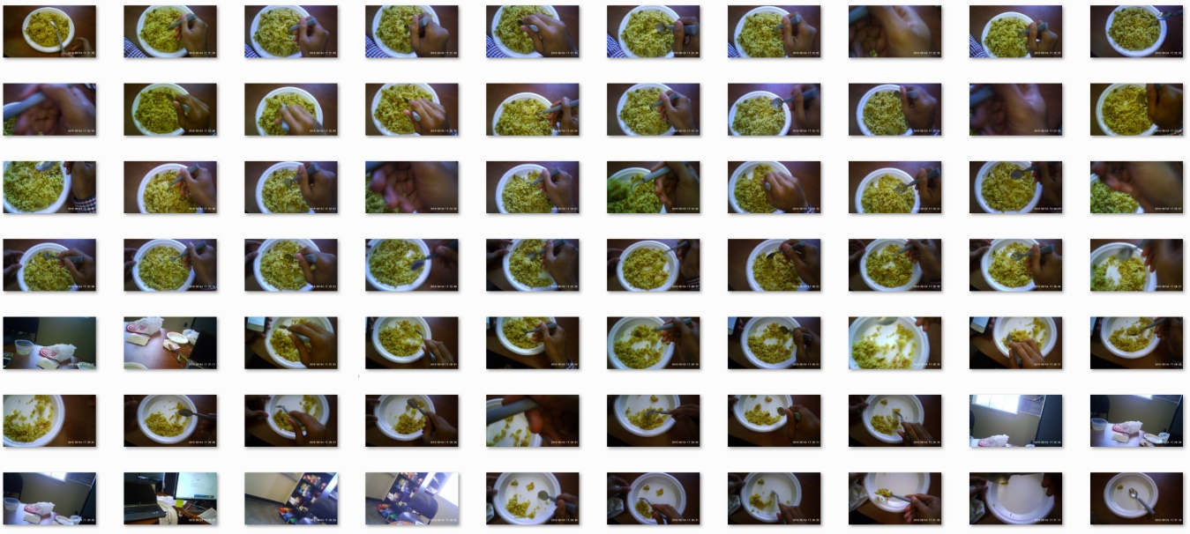
Figure 3. Example of images acquired by the AIM.

2.1.2 Foot pedal
The chewing sequences will be marked using a foot pedal (Fig.4) which will be used only for the meals consumed in the lab. When consuming food, the participants will press the pedal at the moment they place food in their mouth and hold the food pedal until the food is fully consumed.

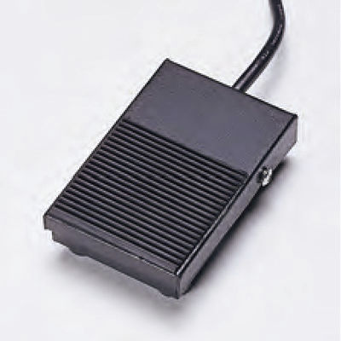
Figure 4. Foot pedal.

2.1.3 3D scanner
A 3D scanner will be investigated for the estimation of the food volume. The 3D scanner is a device that allows capture of a physical object's exact size and shape into the computer world as a digital 3-dimensional representation. Collected data can then be used to construct digital 3D models for volume estimation. The 3D scanner will potentially improve the energy density estimation. An example of 3D scanner is shown in Fig.5.
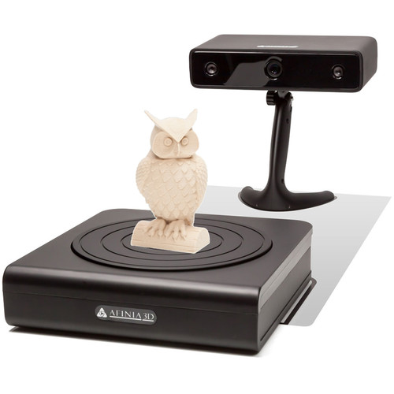
Figure 5. Example of 3D scanner.
2.2 Experimental protocol:
Participants will come to the laboratory for two visits and spend around 1-2 hours in each visit. At the first visit, the participant will go through screening process including informed consent and necessary training. At the second visit, the experiment will begin. The experiment will have two parts – laboratory part, and free living (community dwelling) part. After the completion of the lab portion of the study, the participants will be instructed to continue with the free living part of the study for 2 days.
Initial visit:
The participants will be asked to come to the human participant laboratory in the morning (between 10:00AM - 12:00PM). Participants will read and sign an informed consent form (Appendix I).
After consent is acquired, participants will complete a food preference questionnaire (Appendix II) about their usual consumption habits for condiments, dressings, and beverages. For example, they will designate whether they normally eat regular or lite salad dressings, regular or diet soda, and type of milk/dairy products (regular, reduced fat /2%, or fat free). Participant's height and weight will be checked and recorded. A custom molded earpiece will be made for each participant as a part of the AIM device (if needed). Then participants will be trained in using the AIM and two mobile applications (ASA24 and aTimeLogger) which they will use to report dietary intake and activity during the free living portion of the experiment.
The screenshots of two mobile applications are shown in Figure 6. The dietary reporting application (ASA24, Appendix III) will be used to report what foods and beverages (including portion size) the participants consumed as well as to capture an image of the food items. The activity log app (aTimeLogger, Appendix IV) will be used to report a predefined set of activities (sleeping, eating, sedentary, physically active (exercise), and walking). The participants will be provided with an Android Smart phone to use the apps and take the pictures.
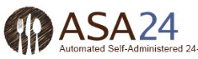
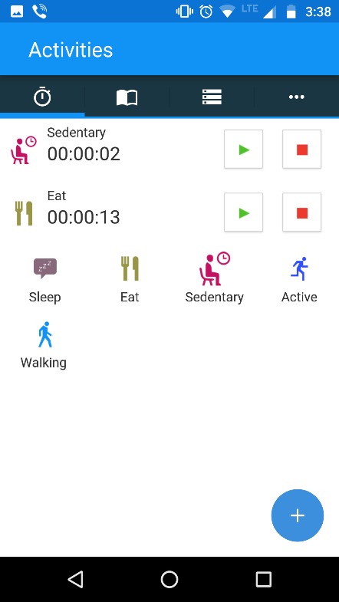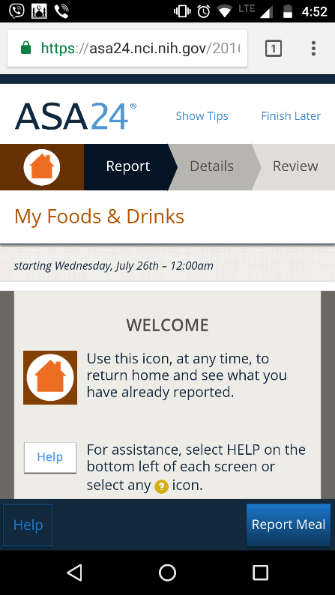
(a) (b)
Figure 6. Screenshots of mobile apps, a) Activity log app – aTimeLogger ; b) meal record app – ASA24

To train participants to enter the portion size of consumed food items accurately, the second part of the training will include necessary training and testing on the process of portion size estimation. Several food replicas will be utilized, for example a scoop of ice cream, one half of an egg, a roasted potato, a pile of brown rice, a bun, a peach, a chicken thigh, and a hamburger (as Figure 7) to train the participants. Then, to ensure that the participants are able to estimate the portion size on their own, they will be given a set of replica foods to estimate the portion size as a competency test. Apart from passing the test, a flyer describing standard portion sizes (Appendix V - visualize your portion size) will be provided so that the participants can use this visual as a guideline during the free living part of study. A summary of the initial visit is given in Table I. After passing the portion size estimation competency test, the initial visit will be complete.
Figure 7. Example of Food replicas (different food replicas could be used in the study based on availability).

Experiment - Laboratory part:
The participants will be asked to come to the human participant laboratory at morning (between 7:00AM - 9:00AM). They will also be instructed to arrive hungry, without having eaten breakfast on any foods, as the first part of the experiment participants will be served a large meal. After arrival, participants will be given instructions for the experiment and given the AIM device.
Participants will perform the activities listed in Table I. Data from the AIM will be collected during every activity. The experiment will proceed with a 'calibration meal' in which participants will be asked to eat a meal while wearing the AIM. The sensor data and food images from the calibration meal will be used in the development of food intake detection models and energy intake estimation models and applied to the data we collect during the free living portion of the study.
The calibration meal will consist of a peanut butter sandwich/chewy chocolate bar, a slice of pizza, an apple, and water. All these food items will be purchased from commercial sources (Bama Dining and/or Walmart). Pizza will be heated in the microwave present in the human research lab upon the request of the study participants. Individuals who identify allergies to any of those food items will be excluded from the study. There will be no restriction on the time required to finish the calibration meal. Participants will be free to talk or drink throughout the eating periods. Each food intake instance (chewing sequences) will be marked using a foot pedal. The research assistant will weigh each food item as it is being served on the plate. In addition, an automatic scale masked in the table will be used to weigh the food items as it is being consumed from the plate. The scale will have the ability to measure the changes in the weight of the plate during the progress of the meal and to send data to a computer using a serial communication in near real time.

Table I: Summary of data collection protocols
Activity | Description | Duration
Initial visit
 | Initial Interview, signing of the informed consent, completing food frequency questionnaire, custom molded earpiece preparation | 20 min
 | Training on mobile apps | 15 min
 | Training on portion size estimation | 20 min
 | Testing on portion size estimation | 15 min
Laboratory Part
1 | Sit silent: sit in a comfortable position | 5 min
2 | Sit while talking: read a document aloud | 5 min
3 | Eat a meal: eat a meal | 20 - 40 min
4 | Walking while silent: walk on a treadmill at a self-selected comfortable speed | 5 min
5 | Walking while talking: walk on a treadmill at a self-selected comfortable speed and talk with the research assistant | 5 min
6 | Walking while eating: eat a chocolate bar while walking on the treadmill | 10 min
7 | Sit silent: sit in a comfortable position | 5 min
8 | Activities of daily living: shelving /stacking items | 5 min
Free living Part
 | Carry out usual daily activities and eating usual diet, with the exception of 3 meals to be consumed at Bama Dining (provided at no cost to participant) | 2 Day

Experiment – Free living part:

After the laboratory part is complete, the participants will be instructed to continue wearing the AIM for the 48-hour period. During this period they will have virtually no restrictions on the types of the activities performed. The participants will continue their normal daily routine with three exceptions:
- They will be instructed to take the AIM off for showering or any other water activities that may damage the device. They will also be instructed to take the AIM off for sleeping.
- They will be instructed to eat what they want when they want it, but asked to come to the lab for consumption of 3 meals (corresponding to their personal definitions of breakfast, lunch and dinner) at the times they choose. These meals will be provided at no cost for the participants at Bama dining or, if prefer, they can bring their own food to the lab. Prior to consumption the foods will be weighed, photographed, 3D scanned and (exact meal content) recorded by the research assistant. Food consumption will be performed similar to the calibration meal. Several participants may be invited to the lab at the same time to simulate social eating.
- Participants will be instructed to report all their eating episodes through ASA24 mobile app and report their activity (from the set of sleeping, eating, sedentary, physically active (exercise), and walking) through aTimeLogger application.
After completing the free living part of the study, the participants will report back to the laboratory to return the AIM and complete a questionnaire about the convenience of using the device (Appendix X).

2.3 Data analysis: Data collected in the study will be used to perform the following analyses:
- Sensor data analysis: The sensor data will be used to detect the AIM's ability to monitor behavioral metrics of food intake (period of food intake, timing, duration, and rate of ingestion of eating episodes) during food intake and validate the performance with reported food intake instances using the foot pedal and food diary mobile apps. The data from AIM will be processed off-line by computer algorithms for recognizing food intake. The results of processing is a file where every 3s-30s time interval will receive a label of "food intake" or "no food intake", resulting in a binary time series signal. Every epoch with food intake will also be characterized by metrics derived from sensor signals such as: number of chews, frequency of chewing, intensity of chewing, chewing rate etc. Models for estimating mass will be developed both as individual (participant-dependent) and group (participant-independent) regressions that will utilize metrics extracted from the AIM sensor data (e.g. number of chews, etc.) to predict mass of each food intake episode.
- Image clustering into food and non-food categories: Clustering techniques will be investigated to identify groups of food image/non-food images within a meal. After clustering food images from all AIM images, high-quality, objective and maximally relevant images will be considered for analysis.
- Image analysis for estimation of energy intake: Estimation of energy density and macronutrient intake from AIM imagery will be performed at the University of Alabama by a trained research assistant. A research assistant will visually identify foods and determine portion size based on container, plate, and cup sizes as they appear in the images following a standard procedure and will estimate each food component and its amount (cups, oz, lb, g, or ml) to obtain the total energy, macro- and micro-nutrient content of food items. The energy density and AIM's estimate of ingested mass can then be used to estimate the energy consumed at each snack and meal.
- Multi-modal estimates models: Energy intake estimation model will be developed using both sensor and AIM images information.
- Food preference questionnaire analysis: Information from food preference questionnaire will be used for accurate energy estimate from images. It will be assumed that the images containing salads, sodas, sandwiches, condiments, cheeses, mixed rice and dairy foods etc, that their “usual” preference was consumed. A correction factor in the model can be used based on the questionnaire.
- Volume estimation: Data from the 3D scanner will be analyzed for the estimation of volume of scanned foods items.

Personnel: The study will be performed by members of the research team at The University of Alabama, which were certified to conduct human participant research. No medical professionals are necessary for this study.

Analysis of outcomes: The goal of this study is to develop and validate AIM device to collect meal images during food consumption and sensor data during an extended period of time (48-hr) from a group of participants performing everyday activities. The collected image data will be used to obtain food images and select potentially relevant food images to be analyzed by research assistant for the estimation of nutrient intake. The sensor data will be used to validate the wearable system to detect periods of food intake under free living conditions. Finally, models for estimating energy intake will be developed utilizing sensor data and food images.

- Study Background

The study of eating behaviors associated with obesity has been problematic due to the reliance on self-report and a lack of accurate tools for monitoring ingestion in free living situations. Traditional and commonly used methods for assessing dietary intake, such as weighed or estimated food records, 24h recalls, and food frequency questionnaires all rely on self-report and are participant to reporting bias, particularly underreporting of Energy Intake (EI). Errors in self-reported intake occur when participants incorrectly report portion sizes and/or foods consumed or change their eating behavior when asked to record intake. Estimates range from 10-50% on average, for underreporting of EI. Previous studies have explored the use of self-report in combination with technology to improve the accuracy of dietary assessment and estimating EI. Audio reports, photographic food records, personal digital assistants and smart cards are some of the methods investigated. Automatic methods for objective dietary assessment based on wearable sensors have been explored as a potential solution to replace self-reported intake. The technological advances in computer vision in recent years have also allowed the introduction of image/video analysis for diet assessment. Food imagery-based method acquires images before, during and after a meal using a wearable camera or a mobile device. However, it may suffer from the limitations of self-reported intake as individuals need to remember to take pictures of the foods before and after consumption. Methods to provide accurate detection and characterization of dietary intake with minimal or no conscious effort from the participants are therefore urgently needed.

The objective of this study is the development of a noninvasive wearable device for automatic and objective food intake monitoring. Apart from that the wearable system will additionally capture high-quality, objective and maximally relevant images of food consumption, enabling accurate nutritional analysis towards developing energy intake models under free-living conditions.

- Participant Population

a. Number of participants: 50 Age range: 18-45 Gender: Male/Female

Vulnerable populations: vulnerable populations, except some children of legal age, will be excluded from the study. As per the National Institutes of Health’s definition of children (e.g., under 18 years of age), the children younger than the age of 18 will not be recruited for the study.

b. Recruitment population, including inclusion/exclusion criteria:

Inclusion Criteria
• Age 18-45 years

Exclusion criteria
• Food allergies, sensitivities, or refusal to eat to any of the foods served in the laboratory meal.
• Inability or not willingness to perform required activities
• Temporo-mandibular Joint disease (TMJ)
• Difficulty with chewing
• Diseases/therapies that create difficulty swallowing or special dietary needs such as cancer.

- Participant Recruitment Methods

Participants will be recruited from advertisements placed around the campus of The University of Alabama. The text for the recruitment announcement is provided in Appendix VI and approval by the Division of Strategic Communications is provided in Appendix VI (a).

Upon contact by email, a response email will be sent to participants briefly explaining the experiment and asking for personal information in order to start the screening for potential inclusion and exclusion criteria (response email is presented in Appendix VII). Screening process will include:

1) Identification of individuals reporting allergies, sensitivities, or refusal to eat to any of the foods in the calibration meal. Individuals reporting at least one of the mentioned conditions will be excluded from the study.

An appointment for the study will be made for participants satisfying the inclusion criteria and they will be informed to come hungry to the experiment as a large meal will be served in the laboratory study. Participants will be provided with an electronic copy of the informed consent document along with the email of appointment. This will ensure that participants have the information prior to their initial laboratory visit.

No protected health or personal information will be collected from the participants.

- Risks

There is a risk of release of personal information. All the information collected during this study will be kept strictly confidential and used for research purposes only. Information obtained in this study is strictly confidential unless disclosure is required by law.

All data will be secured in a locked filing cabinet and in a password protected computer, to which only the researchers will have access. Participants’ names will not be recorded or used in the reporting of information in publications or conference presentations. When the results are presented in research proceedings it will be presented as a whole. Individual participants will not be able to be identified in any way. All individual information will be erased following this study.

The AIM device is a non-significant risk (NSR) device as explained in the "Study Procedure" section above. In order to meet FDA regulations, the packaging of the AIM device (an eyeglass pouch) will be affixed with a label identifying the Dr. Sazonov’s laboratory at the University of Alabama as the manufacturer along with the following statement: “CAUTION - Investigational Device. Limited by Federal (or the United States) law to investigational use.”

- Evaluation of Level of Risk

Minimal.

- Special Precautions/Safeguards Against Risk

Because of the low risk, adverse events are not anticipated. Participants will be informed to contact study personnel immediately if they experience any adverse events. We plan to present all adverse events data to the University of Alabama, respectively, throughout this trial.

- Benefits

There is no direct benefit to the participants in this study.

The benefit to society is that results of this study may provide researchers and clinicians with an inexpensive and unobtrusive method of monitoring food intake under free living conditions. Successful development of such system will help to study and design interventions that will advance the ability to prevent and treat obesity and other eating disorders.

Risk-benefit relation for this study is: Minimal risk, no direct benefit to participant.

- Privacy and Confidentiality
Confidentiality of all records will be strictly maintained by established procedures. Volunteers will be identified in computer files only by a coded participant ID. Only the PI will have access to these codes. All hard copies of data related to this study will be stored in a file cabinet located in the PI’s office. The office is locked when the PI is not present.

- Incentives and Compensation
Participants will receive four free meals and a remuneration of $80 at the end of the study. Participants who do not complete the study, or participants with missing data will receive a prorated remuneration for their time.

- Costs to Participants
No cost to participants is anticipated.

- Care for Research-Related Injury

The research is minimal risk and no research-related injuries are anticipated

- Informed Consent Process

Informed written consent will be obtained by a member of the study team who has been trained according to institutional guidelines. Volunteers will meet with a study representative in a private and quiet room and will be permitted ample time to read the document in a quiet room and an unhurried setting. The study representative will be present to answer questions regarding the study or procedures, should they arise. Once the volunteers have read over the document, the study representative will review the entire document with the participant to be sure that the procedures and time commitments are understood. The volunteer’s comprehension and autonomy will be assessed by asking participants to explain the purpose of the study in their own words. The participant will initial the bottom of each page once this has been done and sign the form. The participant will receive a copy of the signed and dated consent document.

- Informed Consent Documentation

The informed consent form is provided in Appendix I. The participant will sign the form indicating his/her agreement to participate in research. Along with the informed consent, the participant will also sign the photo release form as in Appendix – VIII. No direct deception that would affect participant is required in this study.

- Assent
This study will not include participants requiring assent.

- Consent/Assent Forms
The informed consent form is provided in the Appendix.

- Appendixes/Attachments

I. Consent from
II. Food preference Questionnaire
III. Meal record app - ASA24
IV. Activity log app - aTimeLogger
V. Visualize your portion size
VI. Advertisement
VI(a). Advertisement approval from the Division of Strategic Communications
VII. Screening email
VIII. Photo release form
IX. Documentation of investigator staff training
X. Device Burden Assessment questionnaire

- Citations

[1] “WHO | Obesity and overweight.” [Online]. Available: http://www.who.int/mediacentre/factsheets/fs311/en/. [Accessed: 08-Mar-2011].
[2] G. Danaei, E. L. Ding, D. Mozaffarian, B. Taylor, J. Rehm, C. J. L. Murray, and M. Ezzati, “The preventable causes of death in the United States: comparative risk assessment of dietary, lifestyle, and metabolic risk factors,” PLoS Med., vol. 6, no. 4, p. e1000058, Apr. 2009.
[3] K. M. Flegal, M. D. Carroll, B. K. Kit, and C. L. Ogden, “Prevalence of Obesity and Trends in the Distribution of Body Mass Index Among US Adults, 1999-2010,” JAMA, vol. 307, no. 5, pp. 491–497, Feb. 2012.
[4] A. M. Prentice, A. E. Black, P. R. Murgatroyd, G. R. Goldberg, and W. A. Coward, “Metabolism or appetite: questions of energy balance with particular reference to obesity,” J Hum Nutr Diet, vol. 2, no. 2, pp. 95–104, Apr. 1989.
[5] J. L. Weber, P. M. Reid, K. A. Greaves, J. P. DeLany, V. A. Stanford, S. B. Going, W. H. Howell, and L. B. Houtkooper, “Validity of self-reported energy intake in lean and obese young women, using two nutrient databases, compared with total energy expenditure assessed by doubly labeled water,” 18-Oct-2001. [Online]. Available: http://www.nature.com/ejcn/journal/v55/n11/abs/1601249a.html. [Accessed: 07-Mar-2011].
[6] C. M. Champagne, G. A. Bray, A. A. Kurtz, J. B. R. Monteiro, E. Tucker, J. Volaufova, and J. P. Delany, “Energy Intake and Energy Expenditure: A Controlled Study Comparing Dietitians and Non-dietitians,” Journal of the American Dietetic Association, vol. 102, no. 10, pp. 1428–1432, Oct. 2002.
[7] N. Day, N. McKeown, M. Wong, A. Welch, and S. Bingham, “Epidemiological assessment of diet: a comparison of a 7-day diary with a food frequency questionnaire using urinary markers of nitrogen, potassium and sodium,” International Journal of Epidemiology, vol. 30, no. 2, pp. 309 –317, Apr. 2001.
[8] J. M. De Castro, “Methodology, Correlational Analysis, and Interpretation of Diet Diary Records of the Food and Fluid Intake of Free-living Humans,” Appetite, vol. 23, no. 2, pp. 179–192, Oct. 1994.
[9] M. B. E. Livingstone and A. E. Black, “Markers of the validity of reported energy intake,” J. Nutr, vol. 133 Suppl 3, p. 895S–920S, Mar. 2003.
[10] W. Mertz, J. C. Tsui, J. T. Judd, S. Reiser, J. Hallfrisch, E. R. Morris, P. D. Steele, and E. Lashley, “What are people really eating? The relation between energy intake derived from estimated diet records and intake determined to maintain body weight,” Am. J. Clin. Nutr., vol. 54, no. 2, pp. 291–295, Aug. 1991.
[11] D.-H. Wang, M. Kogashiwa, and S. Kira, “Development of a new instrument for evaluating individuals’ dietary intakes,” J Am Diet Assoc, vol. 106, no. 10, pp. 1588–1593, Oct. 2006.
[12] D.-H. Wang, M. Kogashiwa, S. Ohta, and S. Kira, “Validity and reliability of a dietary assessment method: the application of a digital camera with a mobile phone card attachment,” J. Nutr. Sci. Vitaminol., vol. 48, no. 6, pp. 498–504, Dec. 2002.
[13] C. H. Kaczkowski, P. J. H. Jones, J. Feng, and H. S. Bayley, “Four-Day Multimedia Diet Records Underestimate Energy Needs in Middle-Aged and Elderly Women as Determined by Doubly-Labeled Water,” The Journal of Nutrition, vol. 130, no. 4, pp. 802 –805, Apr. 2000.

